A91-EUR-Greece-Corinth-Demeter, Seated-Terracotta Figurine, 6th-5th century BCE 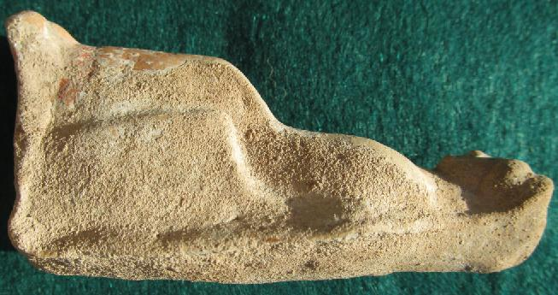

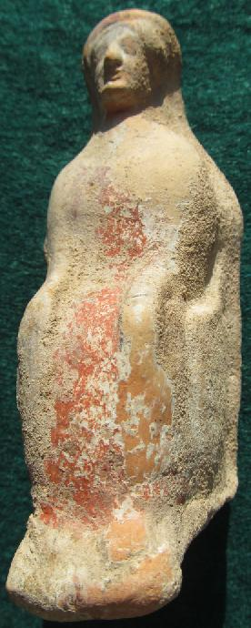

Figs. 1-2. Greece-Corinth-Terracotta Figurine, Seated Demeter, 6th-5th century BCE **Case No.: 4**

**Formal Label:** Greece-Corinth-Terracotta Figurine, Seated Demeter, 6th-5th century BCE This 6th-5th century BCE terracotta, votary figurine of a seated Demeter was produced by Corinthian Greek mid-wives, possibly immigrants from Cos in the Dodecanese where Demeter as the goddess of Mid-wives originated. Original black pigment can still be discerned in outlining her eyes, hands, legs and hair. Round firing hole on base. The present figurine wears a chiton indicated by a red slip over which is a long himation gown, which runs close to her body. Covered by a veil and with her long-flowing hair she projects an aura of serene, benevolent majesty: her feet are on a footstool, her hands are resting on her thighs as though listening to a suppliant patient.

Demeter was one of three Greek deities (along with Artemis and Hera) who presided over childbirth. In an annual procession on the Island of Cos and later in Corinth, girls and older women were led by a priestess of Demeter, who was dressed in the garb of the deity like this figurine. The entourage carried terracotta figurines similar to this one as instruments of healing power, as Demeter's group went from domicile to domicile chanting songs to entreat the deity to intercede on behalf of young betrothed or married women for an easy labor. ***Therefore, the Demeter cult was created by indigenous Greek women on the Island of Cos: it was not an exclusively agrarian fertility cult derivative of Oriental ideas as had been previously thought*** (Robertson 1974: 144). Now we are able to appreciate how figurines such as this one document the history of women mid-wives in Classical Greece.

**Accession Number:**

**LC Classification:** NB.150.R57

**Date or Time Horizon:**

**Geographical Area:**

**Map, from http://www.villakos.com/attachments/Image/map_greece.gif**

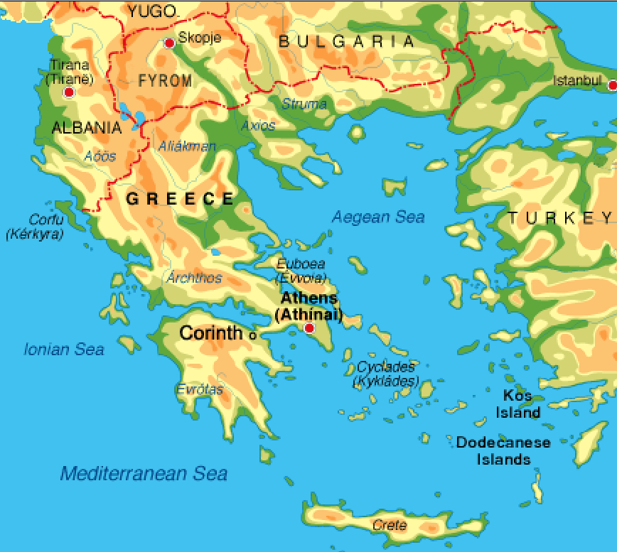

**Fig. Map Eastern Greece**

**GPS Coordinates:** [37°56′N 22°56′E](https://tools.wmflabs.org/geohack/geohack.php?pagename=Corinth&params=37_56_N_22_56_E_type:city_region:GR)

**Cultural Affiliation:** Classical Greece

**Geographical Area: Greece**

**Medium:** terracotta

**Dimensions**: 10.89 cm. (4.29 in.) high; 78.9 gm. (2,78 oz.).   
**Weight:**

**Provenance: Old U. K. Collection**

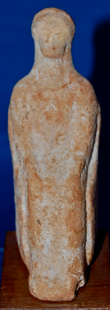Similar to http://kcl-antiquities.co.uk/an-excellent-mounted-ancient-greek-terracotta-stattuette-of-the-goddess-demeter-found-at-corinth-sold-281-p.asp: “Keith Lloyd: An excellent mounted Ancient Greek terracotta statuette of the Goddess Demeter found at Corinth, Central Greece in the early 20th Century and from an old West Country collection. Demeter is depicted in typical poise, wearing a veiled headdress and seated upon a throne with her hands resting in her lap [sic.]. Probably once painted with pigments (now gone), feint barely noticeable repair to neck otherwise Demeter is totally intact and in very nice condition for her great age. 102mm tall (122mm on plinth) x 34mm wide x 52mm deep”

Fig. Keith Lloyd: An excellent mounted Ancient Greek terracotta statuette of the Goddess Demeter found at Corinth

**Condition:** original

**Discussion:**

The worship of Demeter had begun in Cos in the Archaic period where it was thought to have been founded by the sons of king Eurypylus, Chalcon and Antagoras, who received the goddess as she roamed in search of her daughter Koré (Κόρη, the Roman Persephone). During the Pelopon­nesian War, Cos, a member of the Delian League and an ally of Athens, was captured and destroyed by Astyochus, the Spartan gen­eral. It was at this point that the cult of Asclepios was thought to have been brought to Cos by Dorians from Tricca in Thessaly (Sherwin-White 1978: 338). At this point two elements became intertwined: the cult of Demeter and that of Asclepios. Together they were essential in the administration of health care after the devastation of the Peloponnesian War.

The timing was fortuitous, because, at this same period on Cos, Hippocrates was practicing medicine and was conducting medical training out-of-doors under a famous plane tree. Besides establishing the ethical principles of the Hippocratic Oath, he was a fervent exponent of observing the patient, documenting the symptoms, and teaching students at the bedside. We know from a dialogue in Aristophanes' *Thesmophoriazusae* that Hippocrates belonged to the Asclepiadai, a group of educated followers of Asclepios (Major 1941; Sherwin -White 1978:262), whose daughter, Hygeia, was renowned as a healer. So, it was in keeping with his membership in the Asclepiadai that Hippocrates received women as students in the art of healing and midwifery under the famous "Tree of Hippocrates."

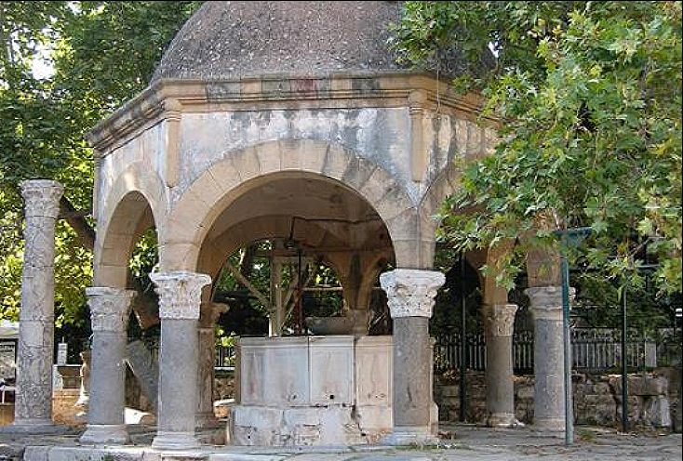

A descendant of the original plane tree beside which is a tablet that reads:

Hippocrates of Cos  
Under the shade of this plane tree  
Instructing and training the youth  
In the art and in the priesthood of medicine  
Instituted this oath  
In the fourth century B. C.

Then, later in the fourth century BCE the Asclepieion of Kos was built on the site of an older temple to Apollo, approximately 4 km southwest of the city (Edelstein and Edelstein 1945; Temki 1953; Angeletti 1991; Edelstein 1937; Bailey 1996).

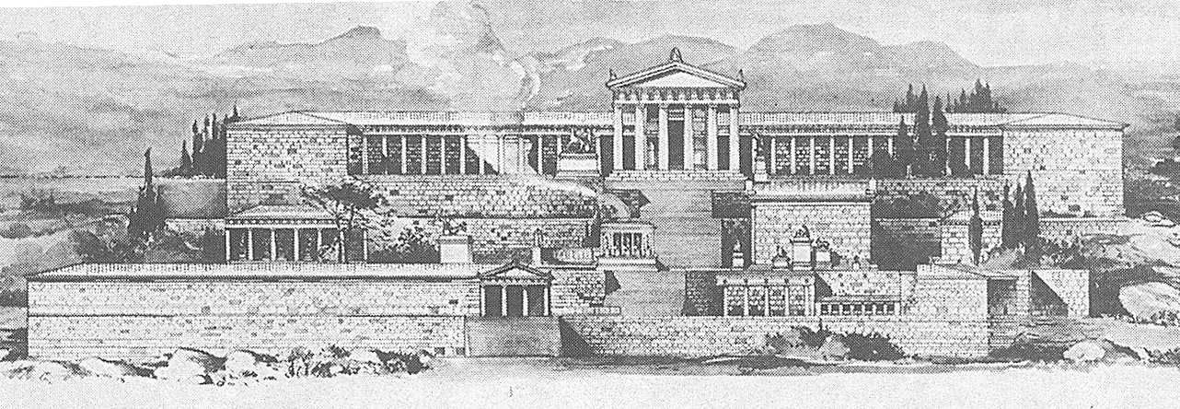

Hellenistic Asclepieion of Kos. After <http://www.arehna.di.uoa.gr/Asclepieio_Kos/scan09.jpg>

Rudolf Herzog the discoverer of the site in 1901 believed that an inscription he excavated is the founding inscription by Thessalus, who was the son of Hippocrates (Gibson 1966; Sakula 1984)!  The Asclepieion of Kos is one of the most beautiful island shrines in the Aegean.

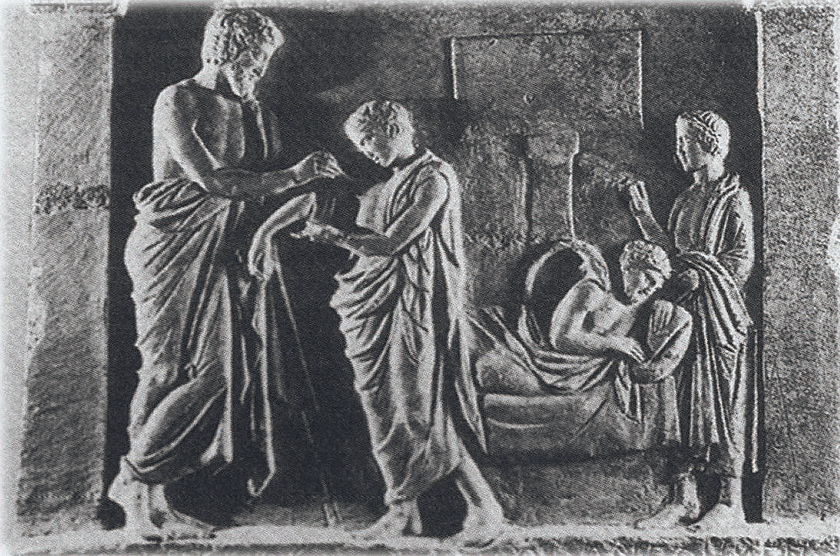

Healing scene from the Hellenistic Asclepieion of Kos. After http://www.arehna.di.uoa.gr/Asclepieio_Kos/HEALING.jpg

This votive statuette of Demeter by Cos mid-wives was a tribute to their goddess, before she became associated with Hygeia and her serpent iconography.

The Demeter-Hygeia iconography of the second half of the fourth century BCE, breaks with the earlier Demeter iconography by emphasizes her holding of the healing serpent (Istituto Storico-Archeologico di Rodi 1928-41: 5(2): 160-161, Figs. 38-39).

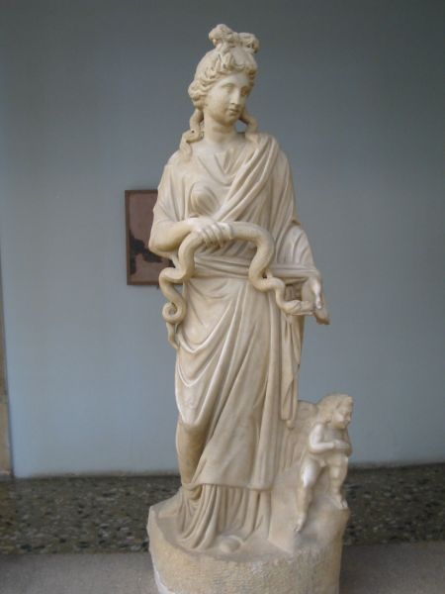 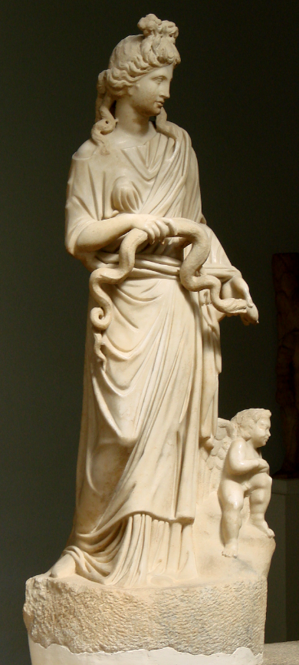

Fig. 3. Demeter-Hygeia holding the serpent from the Metropolitan Museum, Kos.

**References:**

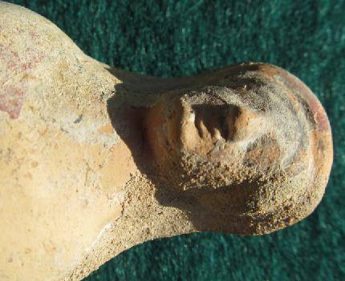



Island of Cos (Κως), where the Demeter mid-wife cult was extensively practiced, off the mainland of southwest Turkey, location [36°51′N 27°14′E](http://toolserver.org/%7Egeohack/geohack.php?pagename=Kos&params=36_51_N_27_14_E_type:city_region:GR).

References:

Angeletti LR. Views of classical medicine. Theurgical and secular rational medicine in the healing-temples of ancient Greece. FORUM Trends Exp. Olin. Mad. 1991; 1: 211.

Bailey JE. Asklepios; ancient hero of medical care. Ann. Intern. Medicine. 1996; 124: 257263.

Edelstein L. Greek medicine in its relation to religion and magic. Bull. Hist. Mad. 1937; **S:** 201-246.

Edelstein EJ and Edelstein L. Asclepius; a Collection *and Interpretation of the* Testimonies. Baltimore: The Johns Hopkins Press, 1945.

Fraser, P. M. 1972. *Ptolemaic Alexandria*. Oxford: Oxford University Press.

Gibson W.S. 1966 Hippocrates' home. Journal of the American Medical Association 197: 110-113.

Istituto Storico-Archeologico di Rodi. 1928-41. Clara Rhodos. Studi e materiali pubblicati a cura dell'Istituto. Rodi, 1928-41.

Major, Ralph H. 1941. Hippocrates on the Island of Cos, *Yale Journal of Biology and Medicine*, 14:1-11.

Robertson, Noel. 1983. Greek Ritual Begging in Aid of Women's Fertility and Childbirth, *Transactions of the American Philological Association*, 113: 143-169.

Sakula A**. 1984.** In search of Hippocrates: a visit to Kos. Journal of the Royal Society of Medicine, 77: 682-688.

Sherwin-White, Susan M. 1978. *Ancient Cos: an historical study from the Dorian settlement to the imperial period.* Göttingen : Vandenhoeck und Ruprecht

Temkin O. Greek medicine as science and craft. Isis 1953; 44: 213-226.

sherwin-White

